**COMPSCI 589: MACHINE LEARNING**

**PROJECT 1 REPORT**

**Student:** Trung Dang – 33858723

1. Task 1

Result:

iteration 0: weight=[-2], cost=[4]

iteration 1: weight=[-1.], cost=[1.]

iteration 2: weight=[0.], cost=[0.]

iteration 3: weight=[0.], cost=[0.]

iteration 4: weight=[0.], cost=[0.]

iteration 5: weight=[0.], cost=[0.]

Below is the plot for the weight history vs cost history

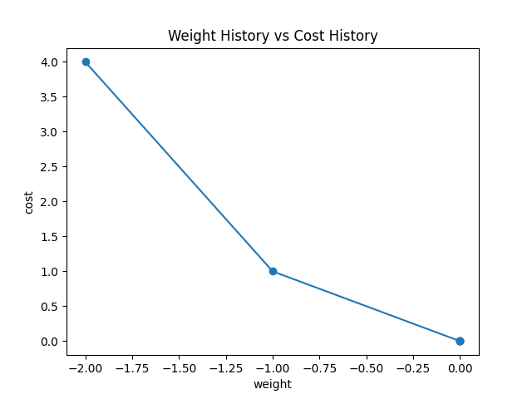

1. Task 2

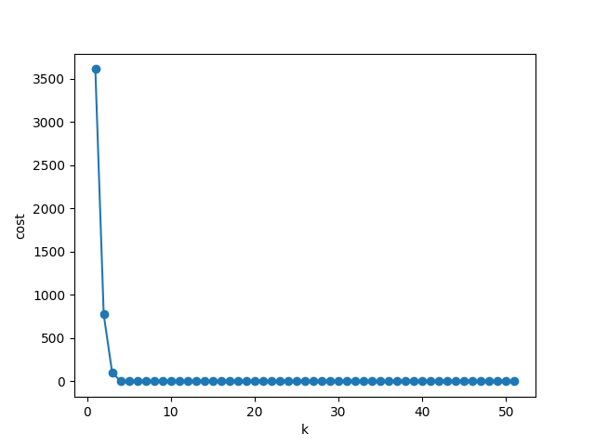

1. Task 3

The plot generated by using all costs value is shown below:

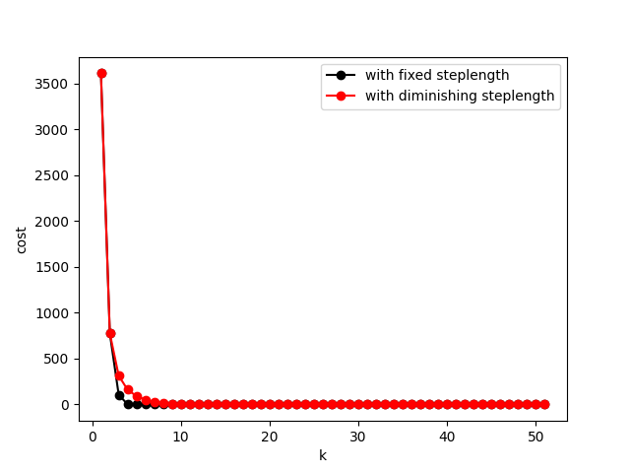

The plot generated by using all the cost data from the 10th index on is:

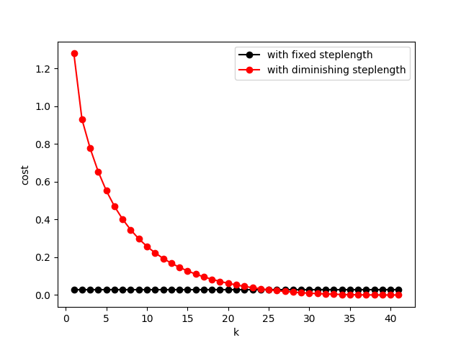

The final cost of task 3 with fixed step length compared to the final cost of task 3 with diminished step length is:

Final cost from fixed step length is: 0.028663876907508132

Final cost from diminished step length is: 3.0852400842917014e-05